Given an m x n matrix board containing 'X' and 'O', *capture all regions that are 4-directionally surrounded by* 'X'.

A region is **captured** by flipping all 'O's into 'X's in that surrounded region.

**Example 1:**

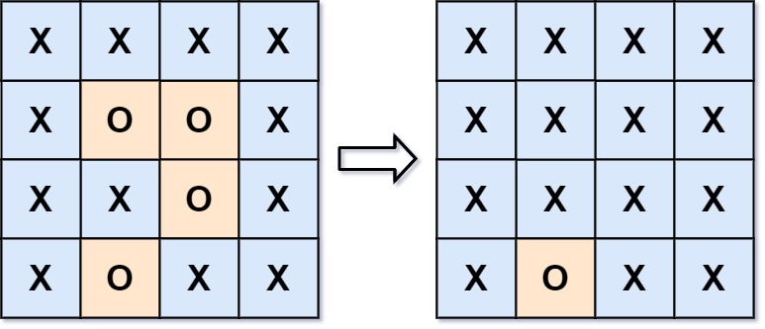

Input: board = [["X","X","X","X"],["X","O","O","X"],["X","X","O","X"],["X","O","X","X"]]  
Output: [["X","X","X","X"],["X","X","X","X"],["X","X","X","X"],["X","O","X","X"]]  
Explanation: Notice that an 'O' should not be flipped if:  
- It is on the border, or  
- It is adjacent to an 'O' that should not be flipped.  
The bottom 'O' is on the border, so it is not flipped.  
The other three 'O' form a surrounded region, so they are flipped.

**Example 2:**

Input: board = [["X"]]  
Output: [["X"]]

**Constraints:**

* m == board.length
* n == board[i].length
* 1 <= m, n <= 200
* board[i][j] is 'X' or 'O'.